Install MPLAB X IDE

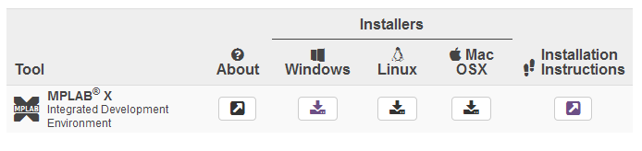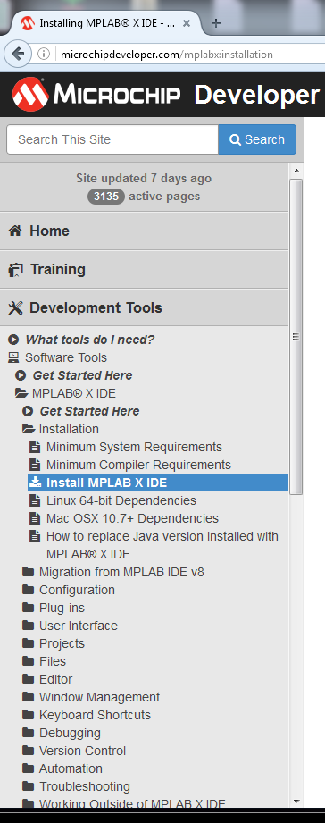

Visit: <http://microchipdeveloper.com/mplabx:installation>

Choose your preferred OS platform installers

Follow Installation Instructions

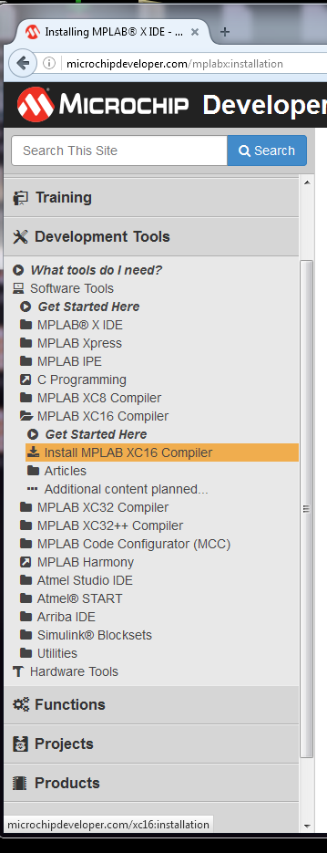Install XC16 Compiler

Navigate to MPLAB XC16 Compiler -> Install MPLAB XC16 Compiler

Choose your preferred OS platform installers

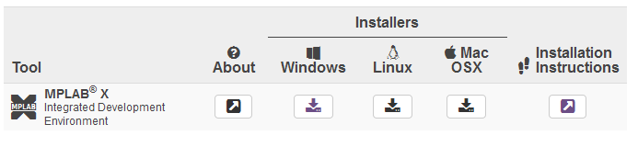

Follow Installation Instructions